July 11 – 15, 2016

Daily from 8:30 AM – 3:30 PM

Seattle Children’s Research Institute
2001 Eighth Ave, Seattle, WA 98121

Presented By:
Social Media and Adolescent Health Research Team (SMAHRT)

Seattle Children’s Research Institute’s researchers study key areas of adolescent health and media and explore research questions like:
- How does Instagram affect teens’
well-being?
- Can you be addicted to the internet?
- Does Facebook influence health behaviors for college students?

What’s in it for you?

Understand careers in health, research and online media

Design and complete a small research project

Gain experience to include on future job or school applications

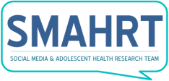
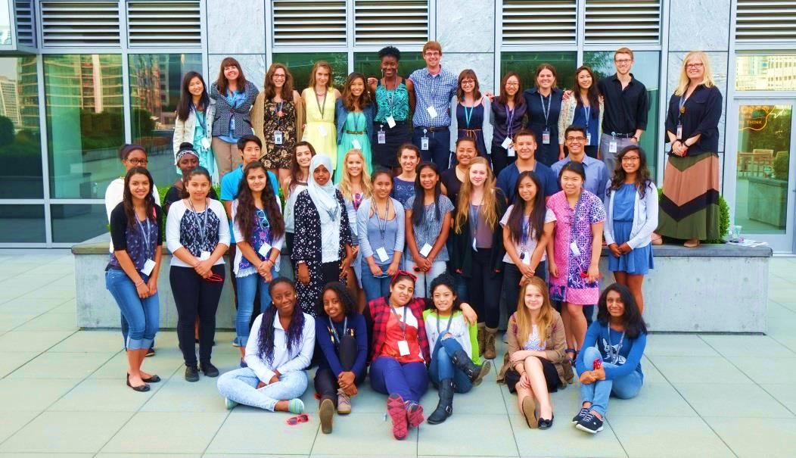
READ MORE: http://smahrtresearch.com/aboutscholars/
APPLY NOW: https://catalyst.uw.edu/webq/survey/uwteen/295229
Please contact us if you prefer a paper application.

About the Program:
If you’ve ever been curious about teen health and media use, the research process, or different careers in health and research, then this week-long scholar experience is for you. Previous research experience is not required.
WHO: Students currently in grades 10, 11, or 12.
WHAT: This weeklong learning experience is a unique opportunity for 25 Summer Scholars to work with and learn from researchers at Seattle Children’s Research Institute.
“I loved meeting new people from all over Washington. And I liked my mentor group and how they got me through my research process. I also loved that I learned new careers that could be in the medical field that isn’t just a doctor.”
-2015 SCRI Scholar

Experiences Include:
- Design your own research project on teen health and social media
- Understand different types of research that seek to improve health
- Learn different career paths in research or health-related fields
- Practice public speaking and presentation skills

Transportation assistance available

Summer Scholars who complete the full week of activities will be provided a $100 stipend
APPLICATIONS DUE MAY 1ST!

